**DOT NET TECHNOLOGIES**

Employee Database With Insert ,Update ,Delete and Display Queries :

**Sample Look Of Application** :

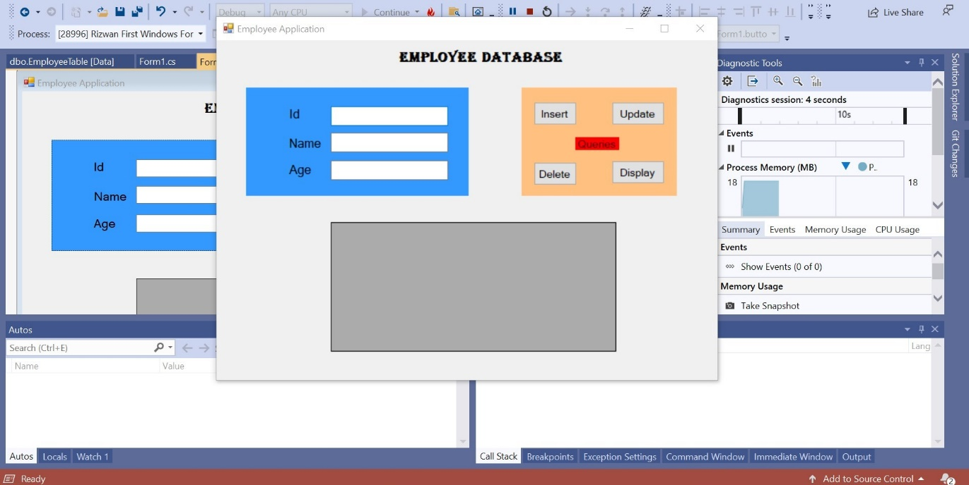

**Insert Query :**

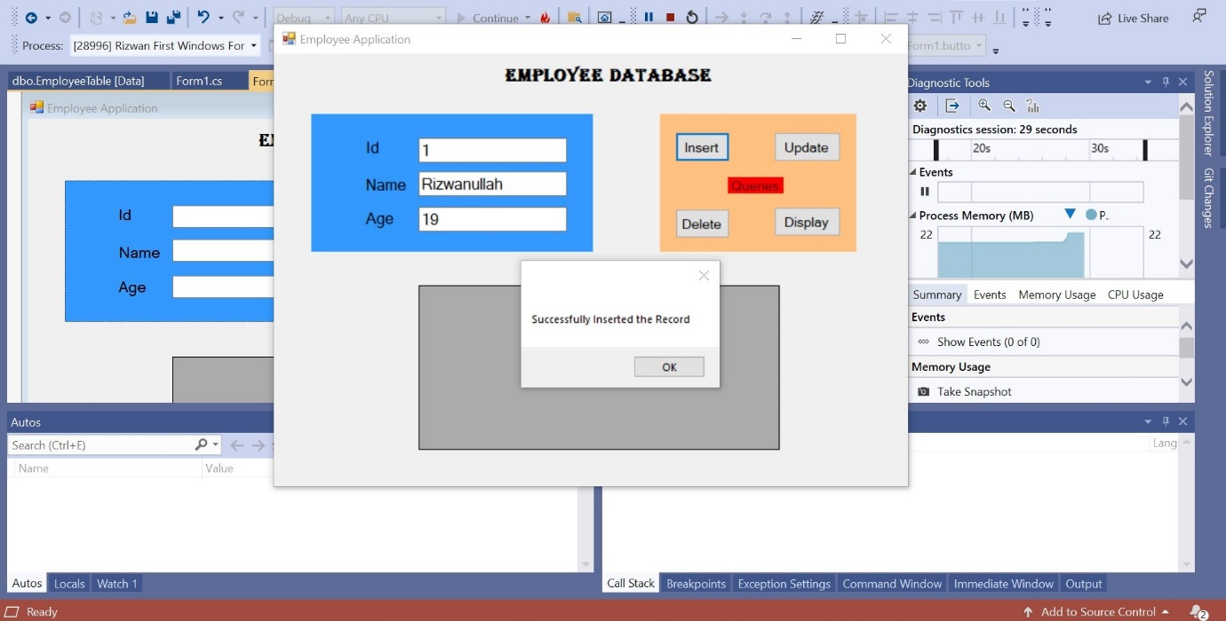

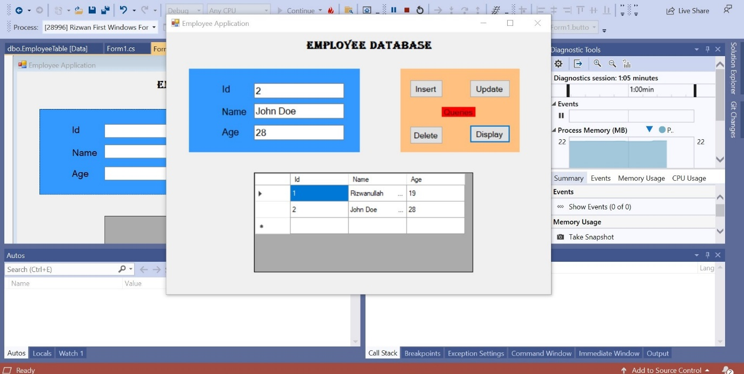

**Update Query :**

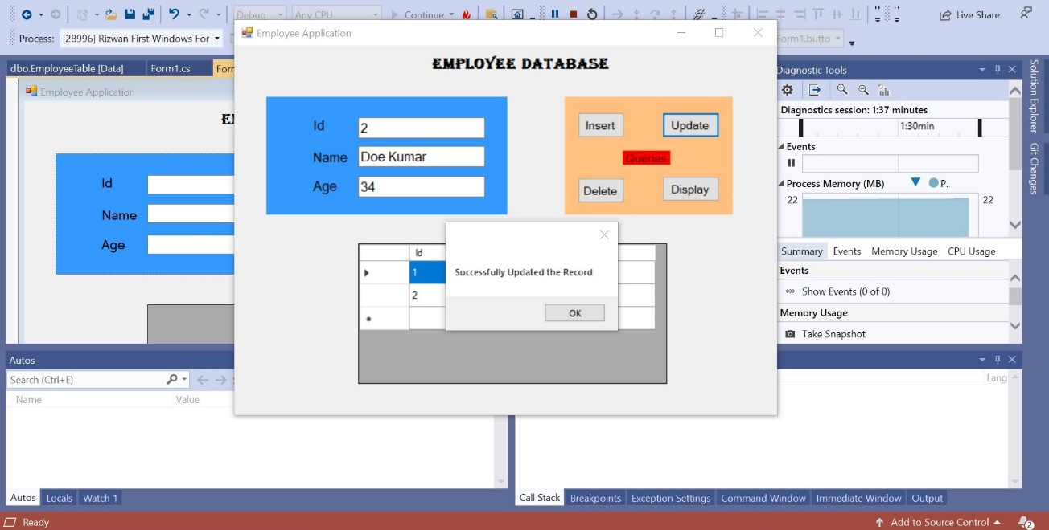

**Display Data In Grid View :**

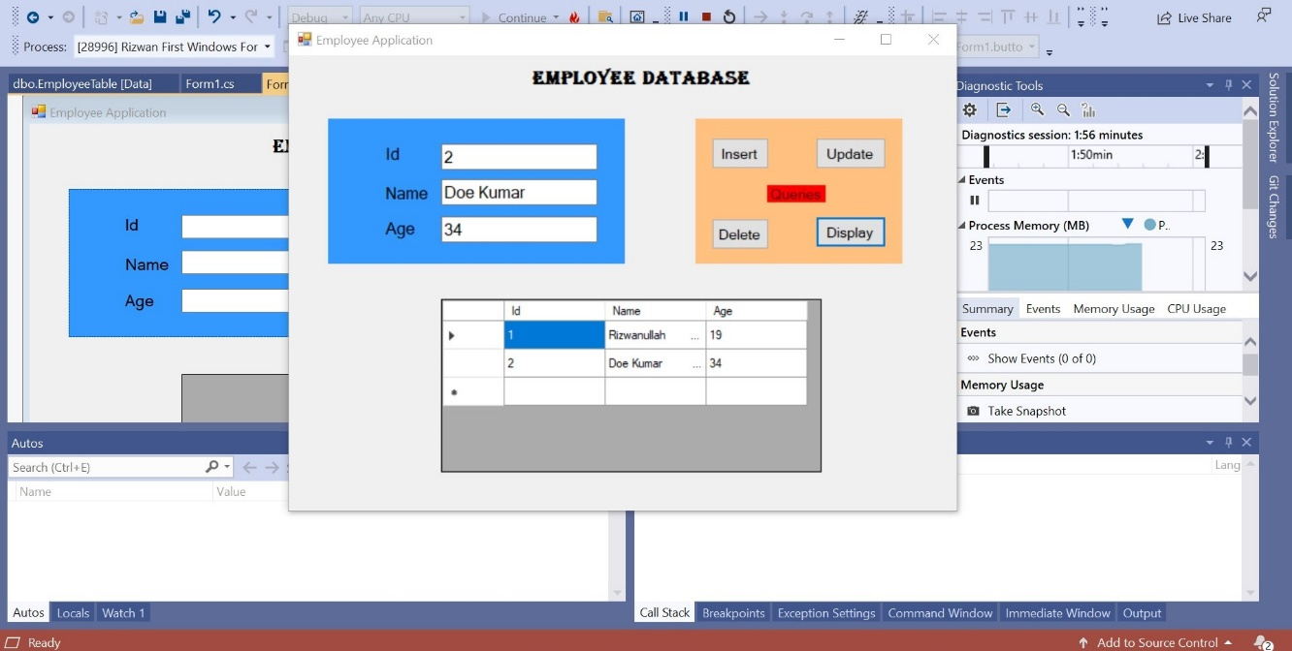

**Delete Query :**

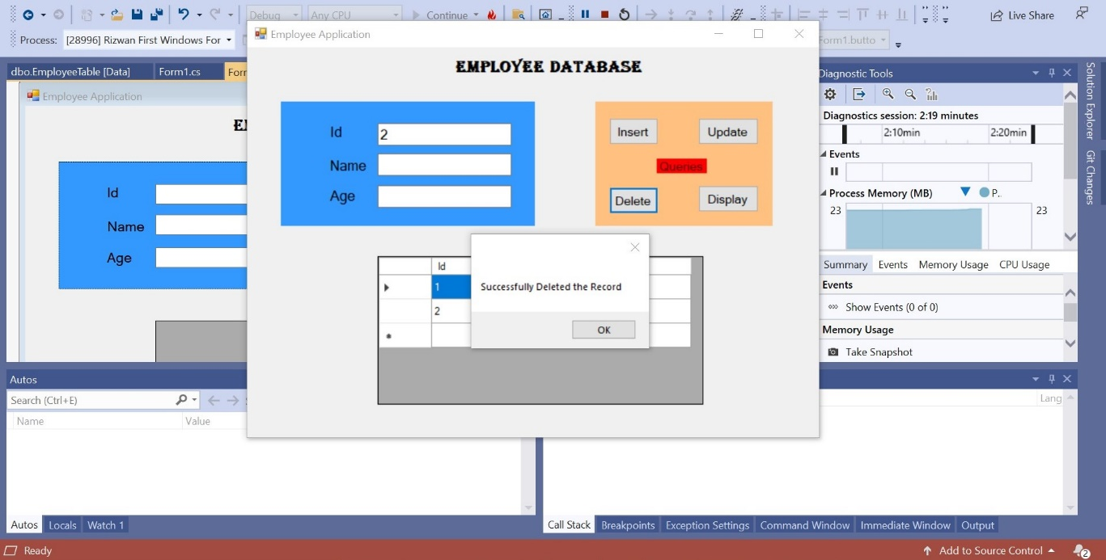

**Display Data In Grid View :**

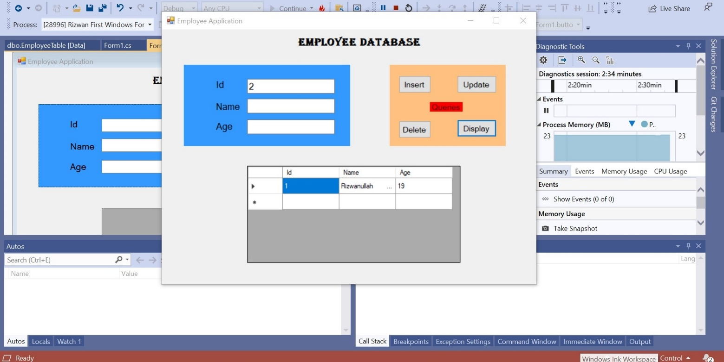

**Code :**

*Form1.cs*

using System;

using System.Collections.Generic;

using System.ComponentModel;

using System.Data;

using System.Data.SqlClient;

using System.Drawing;

using System.Linq;

using System.Text;

using System.Threading.Tasks;

using System.Windows.Forms;

namespace Rizwan_First_Windows_Form

{

public partial class Form1 : Form

{

public Form1()

{

InitializeComponent();

}

private void button1_Click(object sender, EventArgs e)

{

SqlConnection con = new SqlConnection(@"Data Source=(LocalDB)\MSSQLLocalDB;AttachDbFilename=C:\Users\hp\Documents\RizwanDB.mdf;Integrated Security=True;Connect Timeout=30");

con.Open();

SqlCommand cmd = new SqlCommand("insert into EmployeeTable values (@Id,@Name,@Age)",con);

cmd.Parameters.AddWithValue("@Id", int.Parse(textBox1.Text));

cmd.Parameters.AddWithValue("@Name", textBox2.Text);

cmd.Parameters.AddWithValue("@Age", double.Parse(textBox3.Text));

cmd.ExecuteNonQuery();

con.Close();

MessageBox.Show("Successfully Inserted the Record");

}

private void button2_Click(object sender, EventArgs e)

{

SqlConnection con = new SqlConnection(@"Data Source=(LocalDB)\MSSQLLocalDB;AttachDbFilename=C:\Users\hp\Documents\RizwanDB.mdf;Integrated Security=True;Connect Timeout=30");

con.Open();

SqlCommand cmd = new SqlCommand("update EmployeeTable set Name=@Name, Age=@Age where Id=@Id", con);

cmd.Parameters.AddWithValue("@Id", int.Parse(textBox1.Text));

cmd.Parameters.AddWithValue("@Name", textBox2.Text);

cmd.Parameters.AddWithValue("@Age", double.Parse(textBox3.Text));

cmd.ExecuteNonQuery();

con.Close();

MessageBox.Show("Successfully Updated the Record");

}

private void button3_Click(object sender, EventArgs e)

{

SqlConnection con = new SqlConnection(@"Data Source=(LocalDB)\MSSQLLocalDB;AttachDbFilename=C:\Users\hp\Documents\RizwanDB.mdf;Integrated Security=True;Connect Timeout=30");

con.Open();

SqlCommand cmd = new SqlCommand("delete EmployeeTable where Id=@Id", con);

cmd.Parameters.AddWithValue("@Id", int.Parse(textBox1.Text));

cmd.ExecuteNonQuery();

con.Close();

MessageBox.Show("Successfully Deleted the Record");

}

private void button4_Click(object sender, EventArgs e)

{

SqlConnection con = new SqlConnection(@"Data Source=(LocalDB)\MSSQLLocalDB;AttachDbFilename=C:\Users\hp\Documents\RizwanDB.mdf;Integrated Security=True;Connect Timeout=30");

con.Open();

SqlCommand cmd = new SqlCommand("select * from EmployeeTable", con);

SqlDataAdapter da = new SqlDataAdapter(cmd);

DataTable dt = new DataTable();

da.Fill(dt);

dataGridView1.DataSource = dt;

}

}

}

**Sql Query:**

CREATE TABLE [dbo].[EmployeeTable] (

[Id] INT NOT NULL,

[Name] NCHAR (30) NOT NULL,

[Age] FLOAT (53) NOT NULL,

PRIMARY KEY CLUSTERED ([Id] ASC)

);